LAB 321Assignment | Type: | LongAssignment
 | Code: | J3.L.P0018
 | LOC: | 650
 | Slot(s): | 15

Title: My Fashion Blog

Background

You are interest in fashion, and you want to share your experience to everyone.
Complete this assignment to do this now
Reference site:http://us-123fashion.simplesite.com/

Program Specifications

Program a web site toshare your experience in fashion, detail functions of this website is described below

Features:
This website contains 3 main functions
- Function 1 : Home page : ( see PIC 01)
  - Display top 4 entry sorted by published date
  - Each entry contains
    - Entry name
    - Icon
    - Description picture
    - Entry description
- Function 2 : About me( PIC 02)
  - Describe about yourself, your favorites
- Function 3 : Contact ( PIC 03)
  - Help user to submit her requests

You do not need to write interface for admin control panel, you can add data manually (use SQL SERVER Management studio).
Note: All data must be load from database, not hard code in page.

Expectation of User interface:
Pic 01 : Home Page
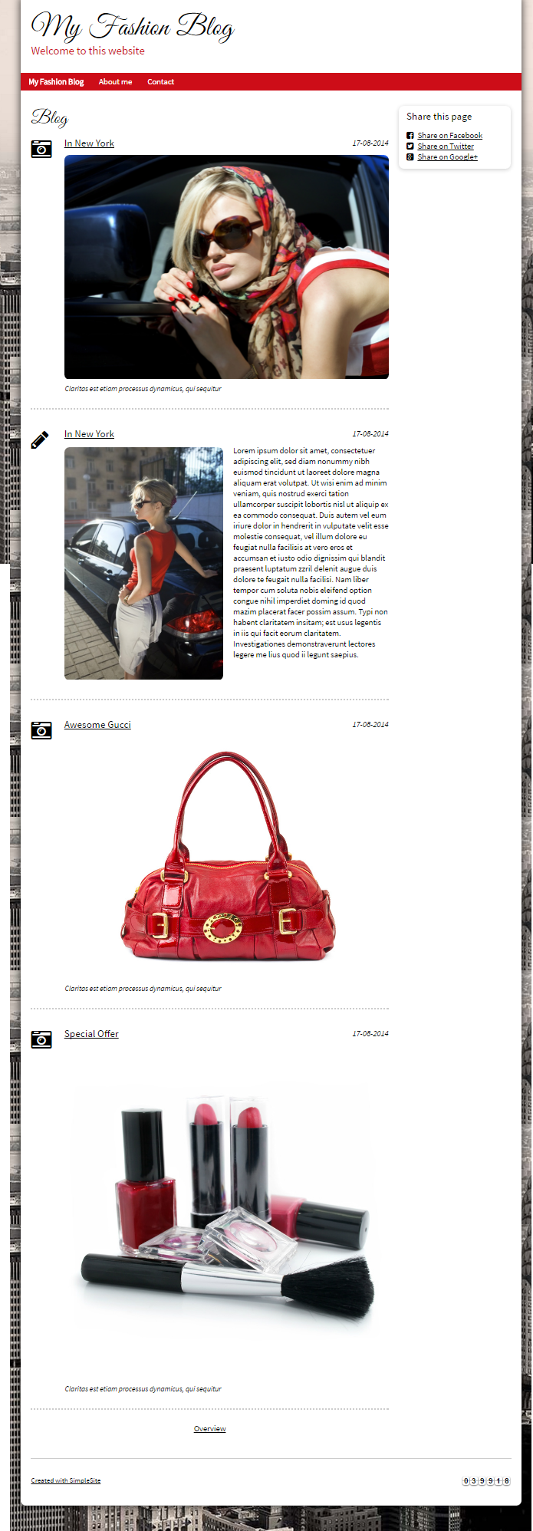
When click to overview, system display all entry detail
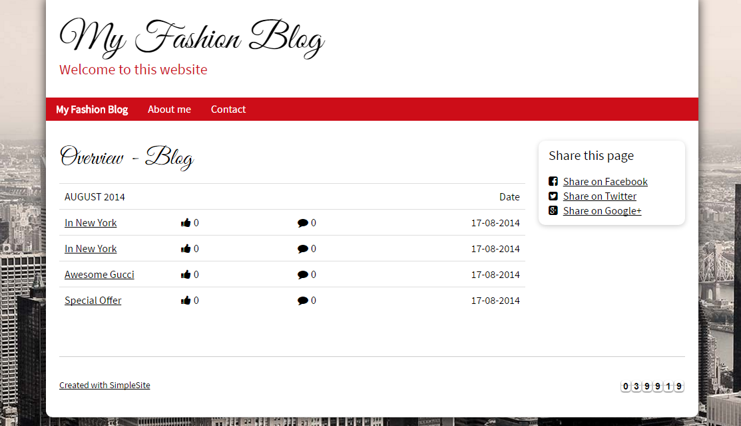

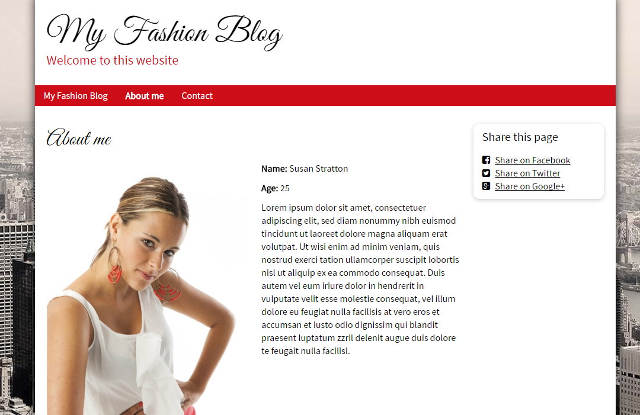
PIC 3 : Contact : allow user to submit message here

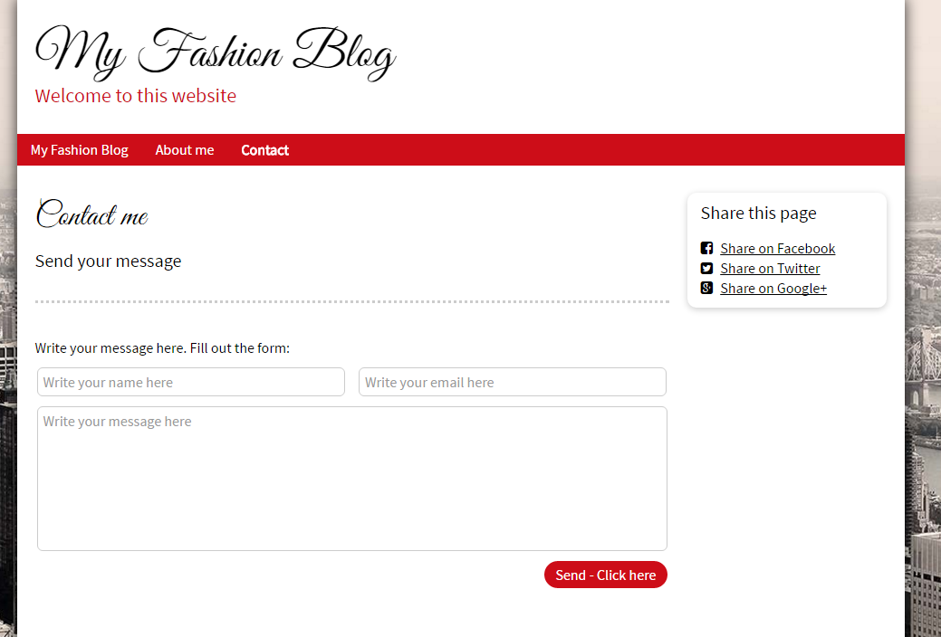

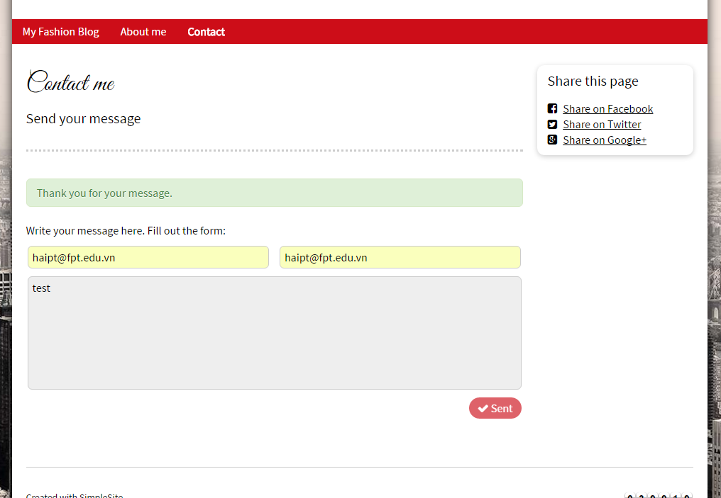
Guidelines
- Step 1 : Create web layout
- Step 2 : Create prototype
- Step 3 : Design database base on created prototype
- Step 4 : Code & Test

